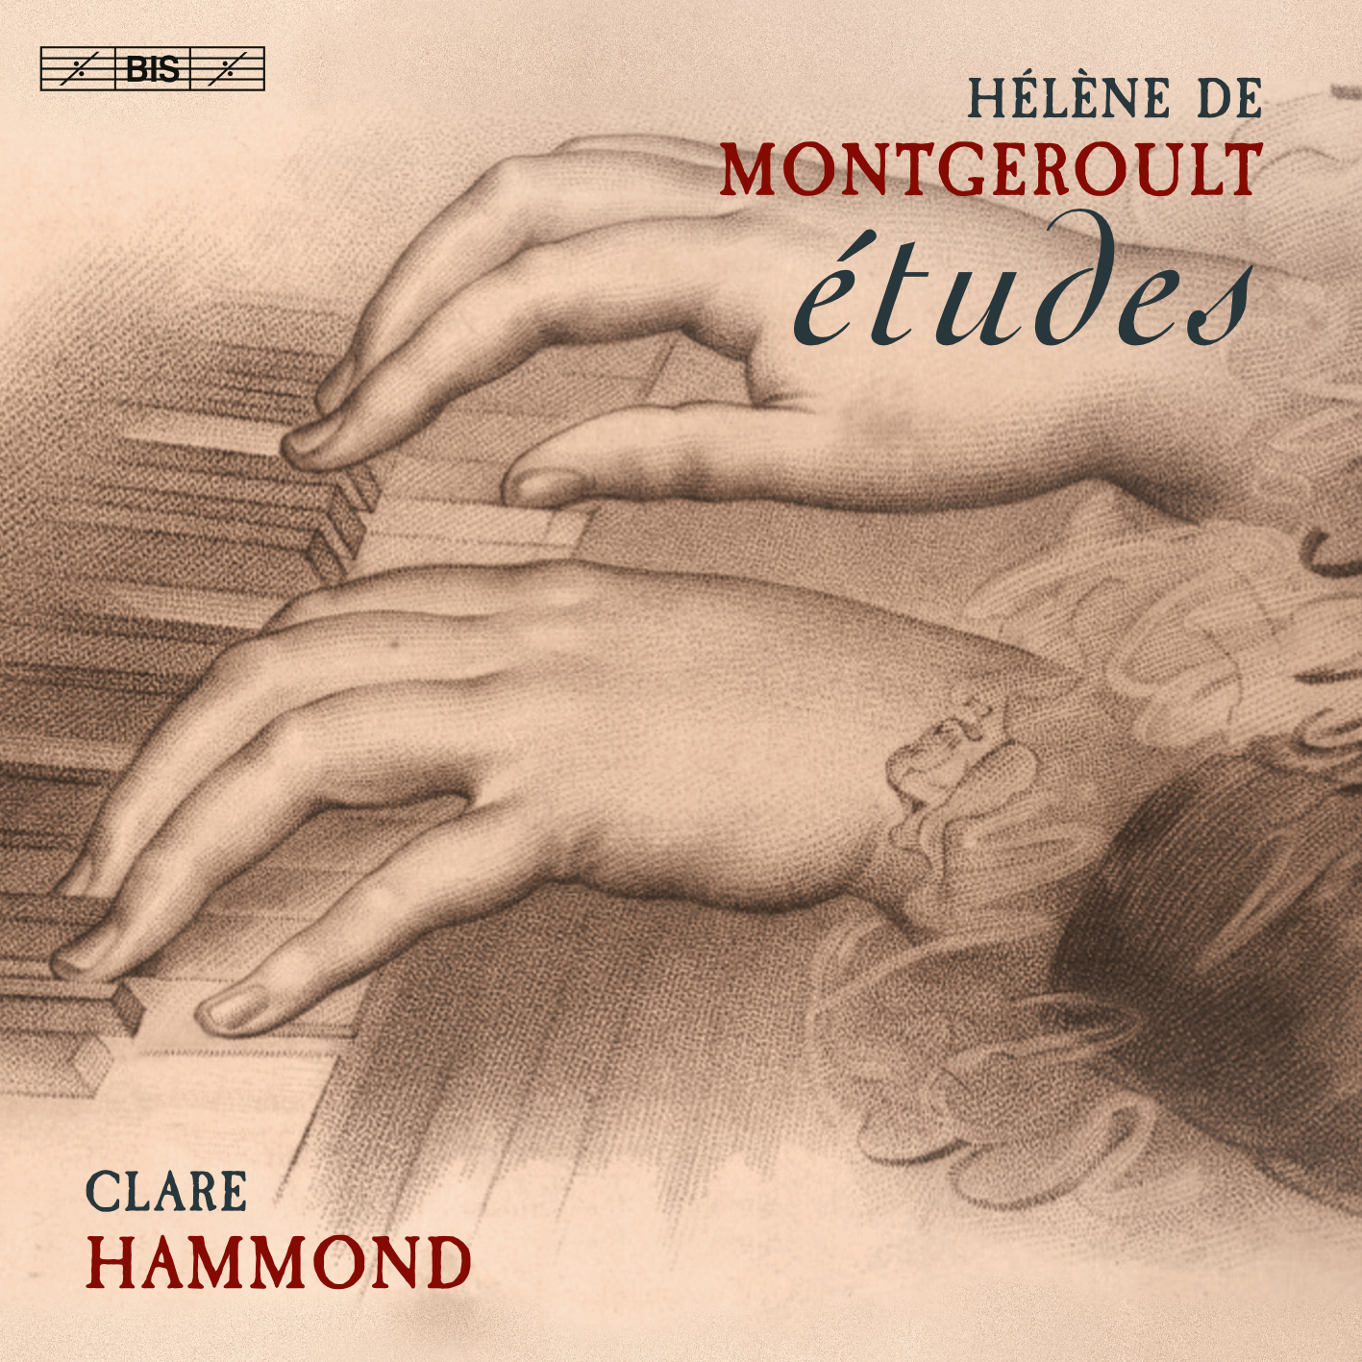
CLARE HAMMOND
piano
“… shimmering pianism and lightly-worn virtuosity”
BBC Music Magazine
"… a pianist of extraordinary gifts"
Gramophone Magazine

PRESS RELEASE: IMMEDIATE
Pianist Clare Hammond releases a disc of études by
Hélène de Montgeroult, with 12 world premiere recordings.
Prison and school project also running in the autumn
On 4 November 2022, Clare Hammond releases her sixth disc for BIS Records with études by visionary composer Hélène de Montgeroult (1764-1836). Eight years younger than Mozart, Montgeroult pioneered a Romantic style that was decades ahead of her time. She was renowned as one of the greatest improvisers in Europe and has been described as “the missing link between Mozart and Chopin”. Neglected because of her gender, it is only recently that her music has been revived.

Born into an aristocratic family, Montgeroult fled France during the Revolution and was involved with exiled political factions in the UK. On her return, she joined a diplomatic envoy to Naples, to be abducted by Austrian soldiers en route and imprisoned. She regained her freedom, but was then put on trial by the Committee of Public Safety during the Reign of Terror. Montgeroult only managed to avoid execution by improvising a set of variations on the Marseillaise that moved the judges to tears.

Montgeroult wrote these études between 1788 and 1812, initially for her pupil Johann Baptist Cramer. Remarkably, they anticipate stylistic advances we associate more closely with the music of Mendelssohn, Schubert, Schumann, Chopin, and even Brahms. One of the first composers to appreciate the artistic potential of the étude, Montgeroult paved the way for the proliferation of concert études by the Romantic generation.

Clare says “when I first encountered these études I was astounded. Not only are they of similar quality to music by Felix Mendelssohn and Robert Schumann, they are stylistically so advanced as to call into question where the ‘classical’ and ‘romantic’ periods fall. I could not believe that she had written such superb and prescient music and yet I had never heard of her.” BBC Radio 3 featured Montgeroult on Composer of the Week in July 2022. Clare will perform her music at the National Gallery (to accompany their Manet / Eva Gonzalès exhibition) and Wigmore Hall in London, the Château de Montgeroult in France, and schools and prisons across the South-West as part of her work to bring classical music to new audiences.

Watch the trailer at: https://www.youtube.com/watch?v=-kGKGxB1yJc
Listen to audio demos at: https://clarehammond.com/press/montgeroult/
Notes to Editors
For further information, press CDs, downloads, photos and interview opportunities, please contact:
Jo Carpenter Music PR Consultancy E: jo@jocarpenter.com T: 07771 538868‬‬‬‬‬‬‬‬‬‬‬‬‬‬‬‬‬‬‬‬‬‬‬‬‬‬‬‬‬‬‬‬‬‬‬‬‬
A dedicated press page for the disc with a press release, trailer, press photos, and audio demos can be found at https://clarehammond.com/press/montgeroult/.

Disc supported by the Ambache Charitable Trust, John S Cohen Foundation, Fidelio Charitable Trust, Gemma Classical Music Trust, Golsoncott Foundation, The Stradivari Trust, Tony Allcock, Miles Dodd, John Wilson, Penny Wright and Andrew Neubauer.
Biography
Acclaimed as a “pianist of extraordinary gifts” (Gramophone) and “immense power” (The Times), Clare Hammond is recognised for the virtuosity and authority of her performances. In 2016, she won the Royal Philharmonic Society's 'Young Artist Award' in recognition of outstanding achievement and in 2020 she was engaged to perform at the International Piano Series (Southbank Centre). In 2022, she appears with the CBSO (Michael Seal) and BBC NOW, performs at the Aldeburgh and Husum Festivals, and gives live broadcasts for BBC Radio 3, and Danish Radio with violinist Henning Kraggerud.

Performances during the pandemic included recitals for the Wigmore Hall and Aldeburgh Music, a live recital broadcast for BBC Radio 3 Lunchtime Concerts from St David’s Cardiff, and broadcast recordings of Moussa and Carwithen with the BBC Symphony Orchestra (Geoffrey Paterson) and BBC Concert Orchestra (Gavin Sutherland). During 2020-21, Clare was engaged to perform with the Britten Sinfonia (Ryan Wigglesworth), Sinfonia Varsovia (Jacek Kaspszyk), Royal Philharmonic Orchestra (Christoph Altstaedt) and the BBC Symphony Orchestra (Dalia Stasevska), while in recent seasons she has appeared with the Royal Liverpool Philharmonic Orchestra (Vasily Petrenko), BBC National Orchestra of Wales (Martyn Brabbins) and Philharmonia (Jamie Philips).

Clare’s discs for BIS have been widely praised with her latest, Variations, receiving extensive critical approval. The disc was commended for its “shimmering pianism and lightly-worn virtuosity” (BBC Music Magazine) and “artistry of the highest order” (Musical Opinion), while Crescendo (Belgium) hailed her as “one of the most exploratory pianistic personalities of our time”. Clare’s discography includes world premiere recordings of over 45 works. Clare completed a BA at Cambridge University, where she obtained a double first in music, and undertook postgraduate study with Ronan O’Hora at the Guildhall School of Music & Drama.

BIS Records, BIS 2603  Release date: 4 November 2022  Total playing time: 70’35  Distributed in the UK by Naxos Music UK.  More information online at:  http://www.clarehammond.com/  https://bis.se/ | Hélène de Montgeroult (1764-1836)  29 études from the Cours complet pour l’enseignement du fortepiano  Nos. 37, 36, 35, 34, 28, 26, 38, 41, 51, 53, 52, 55, 66, 62, 65, 67, 74, 89, 82, 97, 99, 100, 101, 103, 106, 104, 107, 110, 111  *With 12 world premiere recordings*

